EVENT MANAGEMENT SYSTEM USING SALESFORCE

INTRODUCTION

OVERVIEW

Event management is the process of creating and maintaining an event. This process spans from the very beginning of planning all the way to post event strategizing.

At the start, an even manager makes planning decisions,such as the time, location, and theme of theiur event. During an event, event managers oversee the event live and make use things run smoothly. After an event, event managers are tasked with reviewing event data.

PURPOSE

This project helps in managing the on going and upcoming events in an organization. Thus for all the students who have basic knowledge of salesforce and looking for a real time project.

This project will also helps to those profesionals who are in cross technology and wanted to switch to salesforce with the help of this project they will gain knowledge and can include into their resume as well.

2.PROBLEM DEFINITION AND THINKING

EMPATHY MAP

An empathy map is widely used visualization tool within the field of UX and HCI practice.

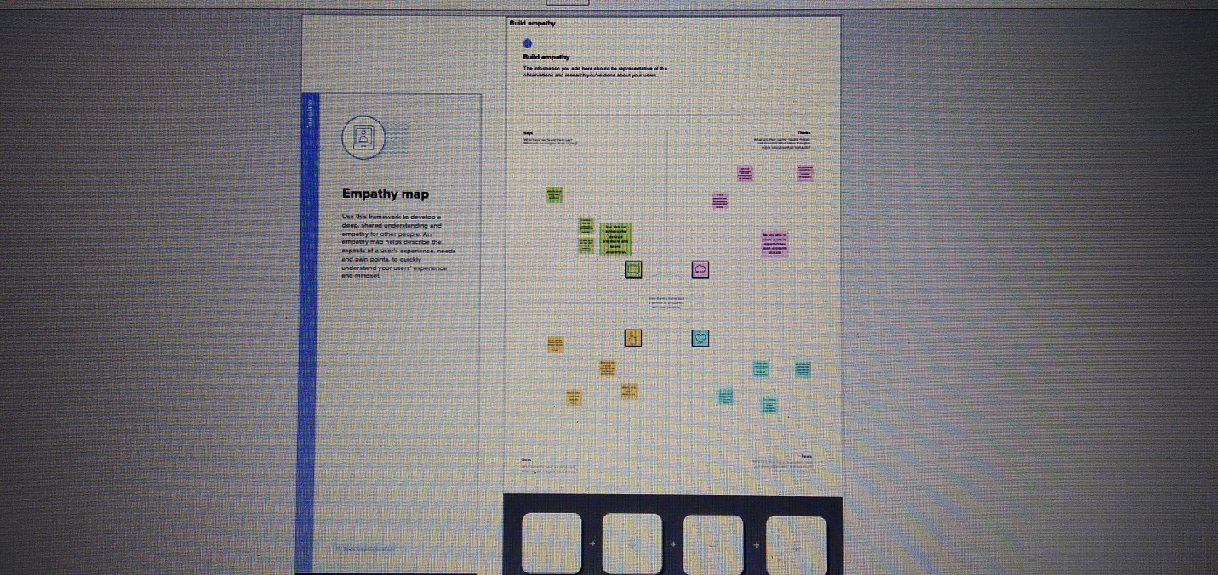

IDEATION & BRAINSTORMING MAP

Brainstorming is the process of generating as many ideas as possible in short amount of time without regarding for organization.

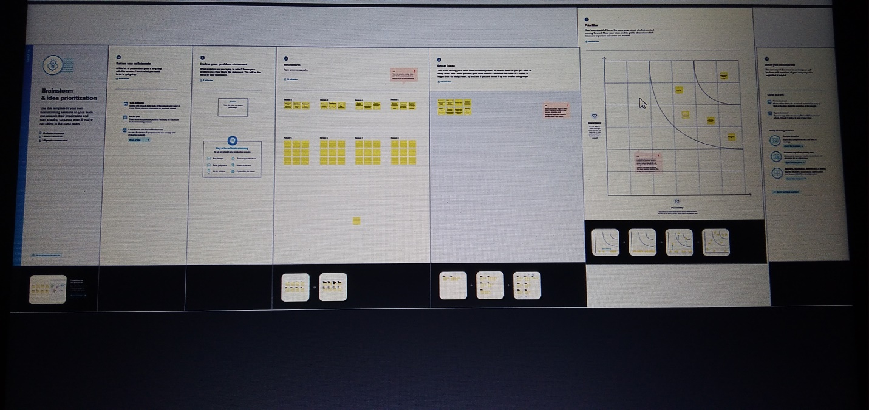

3.RESULT

DATA MODEL

|  |  |  |
| --- | --- | --- |
| OBJECT | DATA TYPE | FIELD NAME |
| events | Text | City |
| attendees | phone | Phone |
| speakers | Text area | Bio |
| vendors | email | Phone |

ACTIVITY & SCREENSHOT

Milestone 2 - object

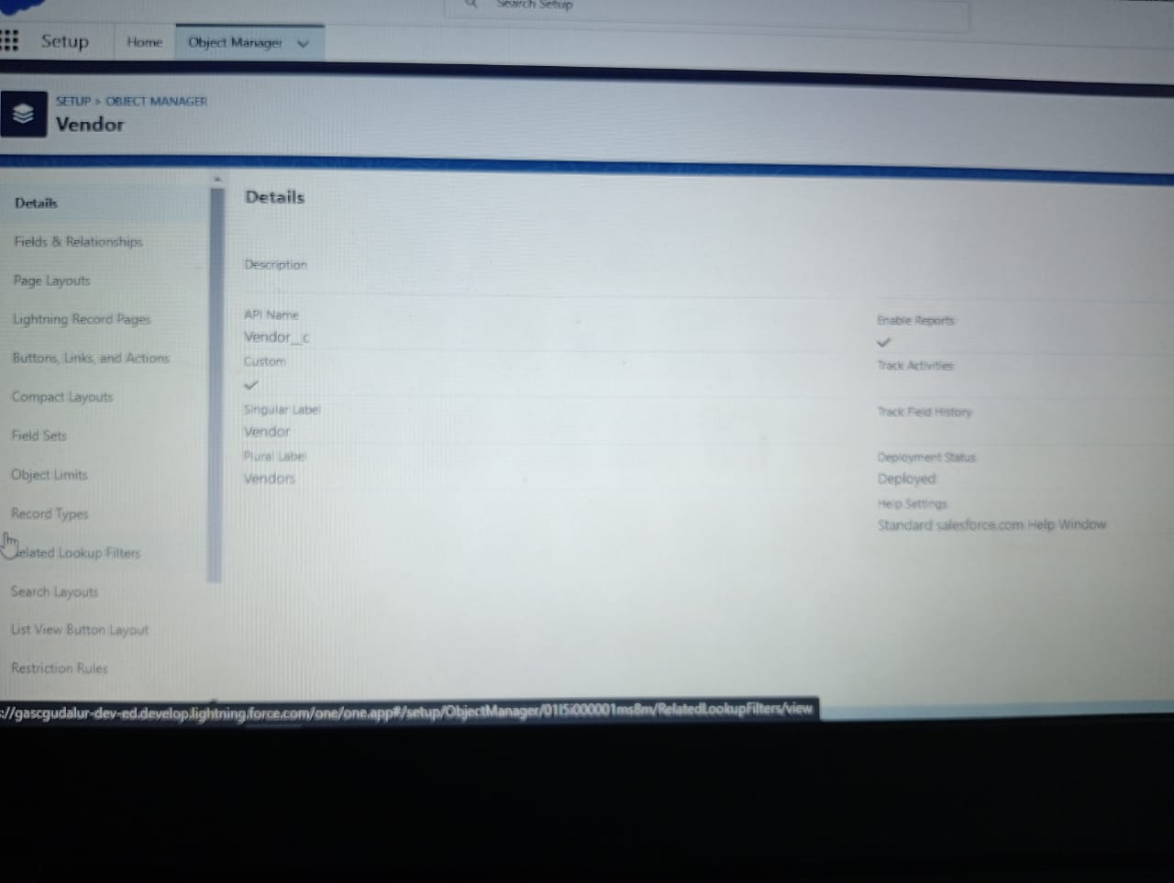











Milestone 3 – tab

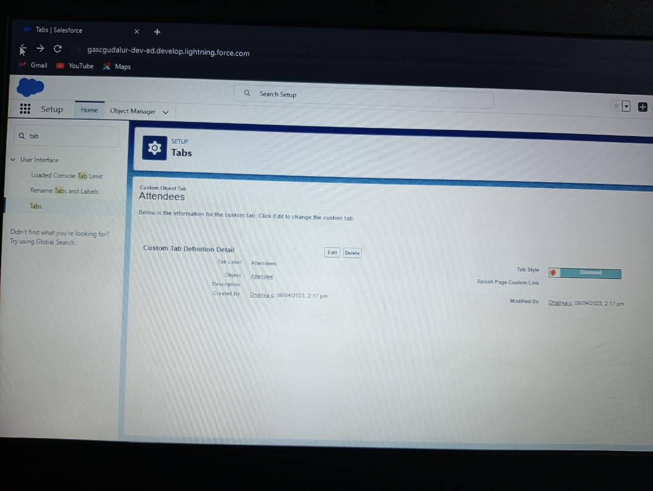



Milestone 4 – field

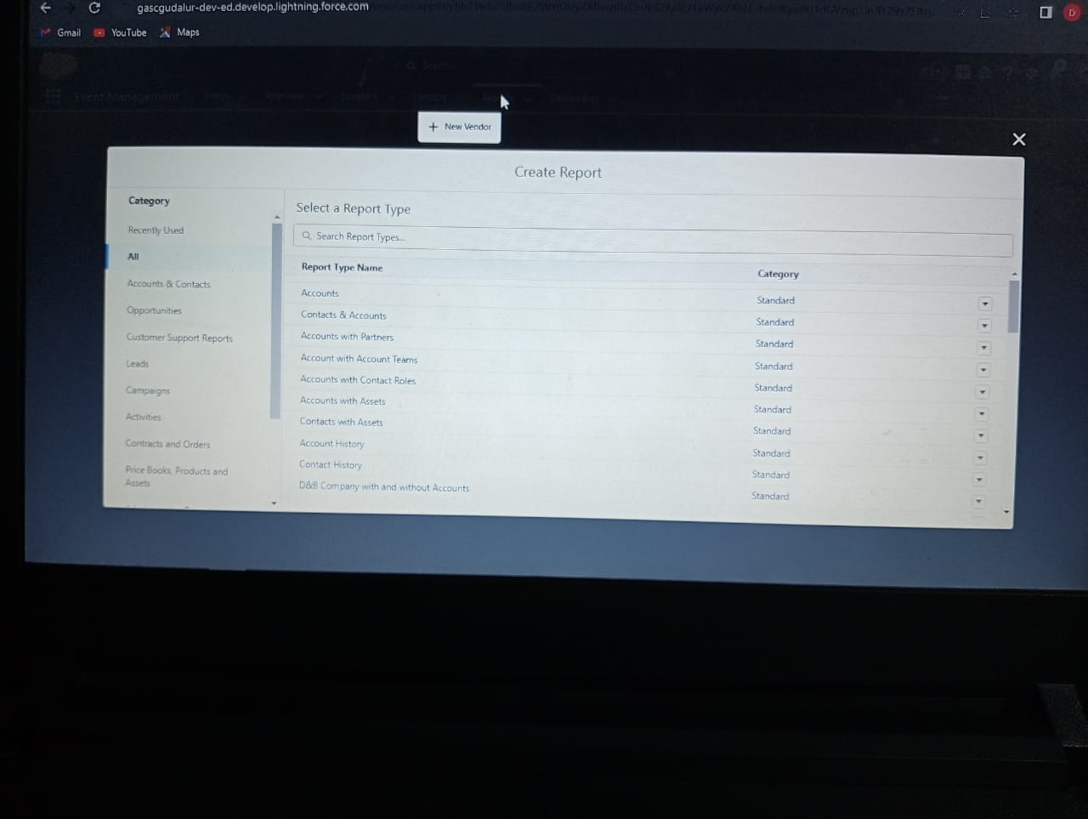

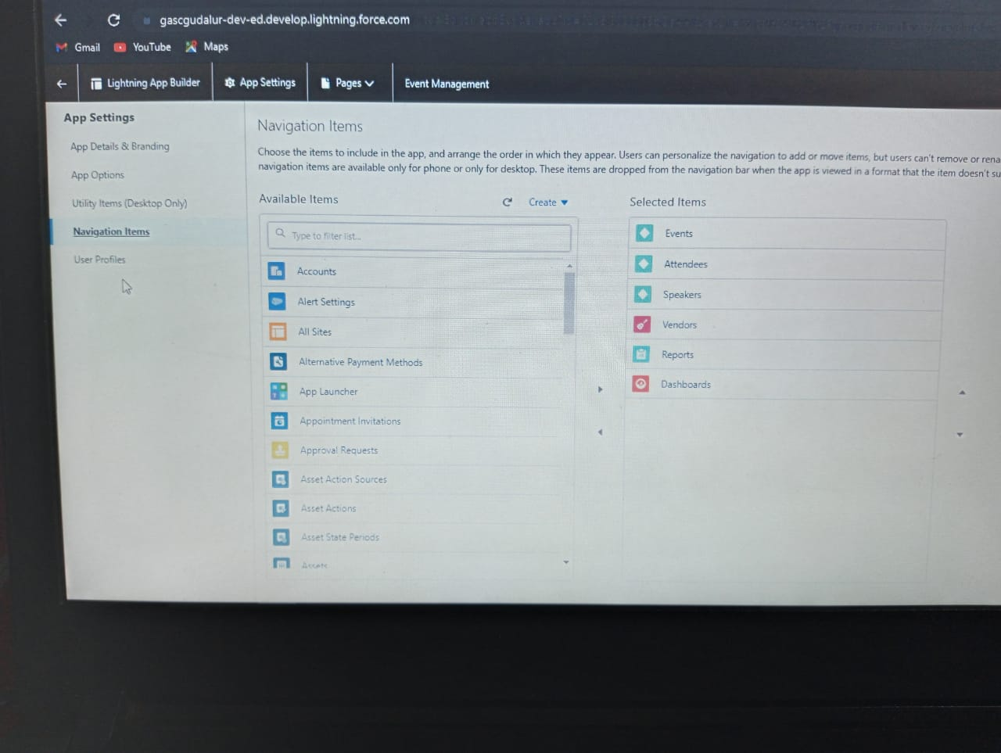

Milestone 5 – profile

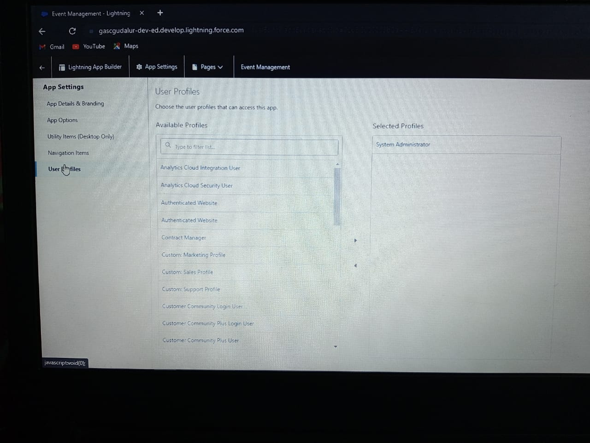

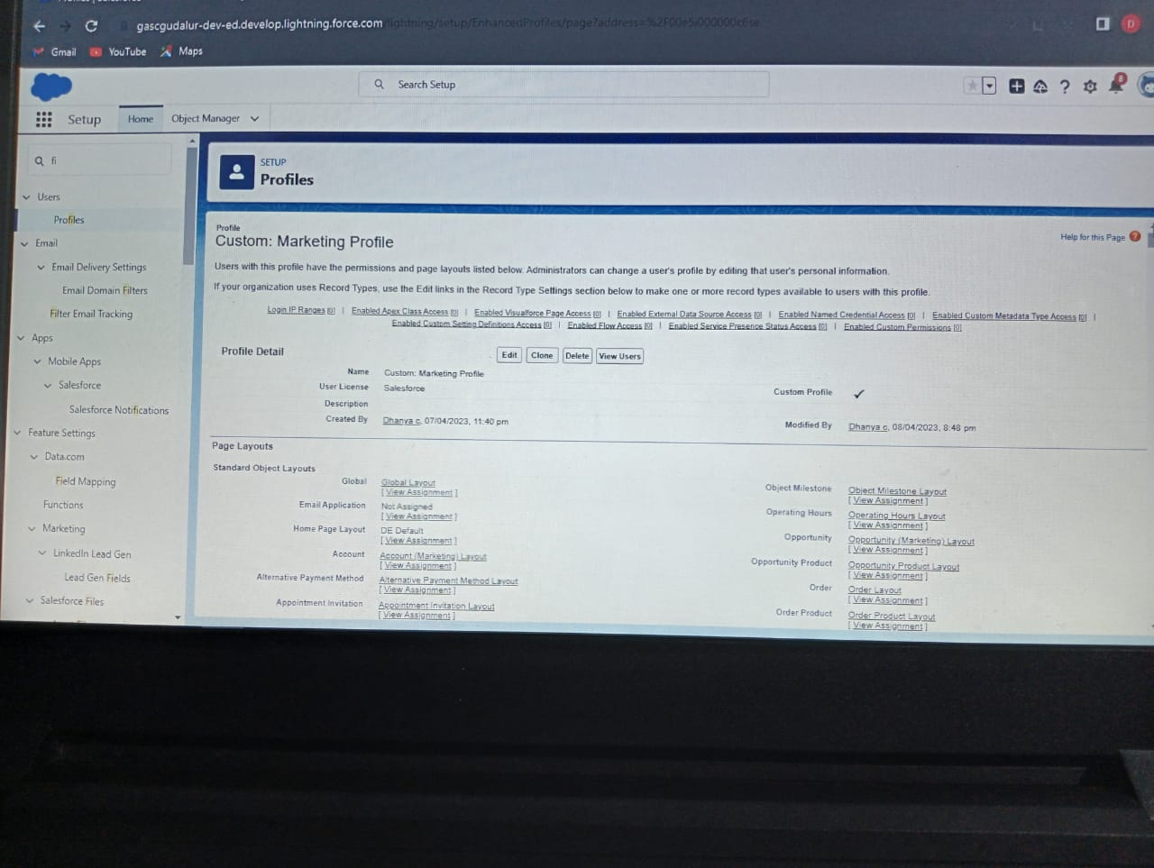

Milestone 6 – user

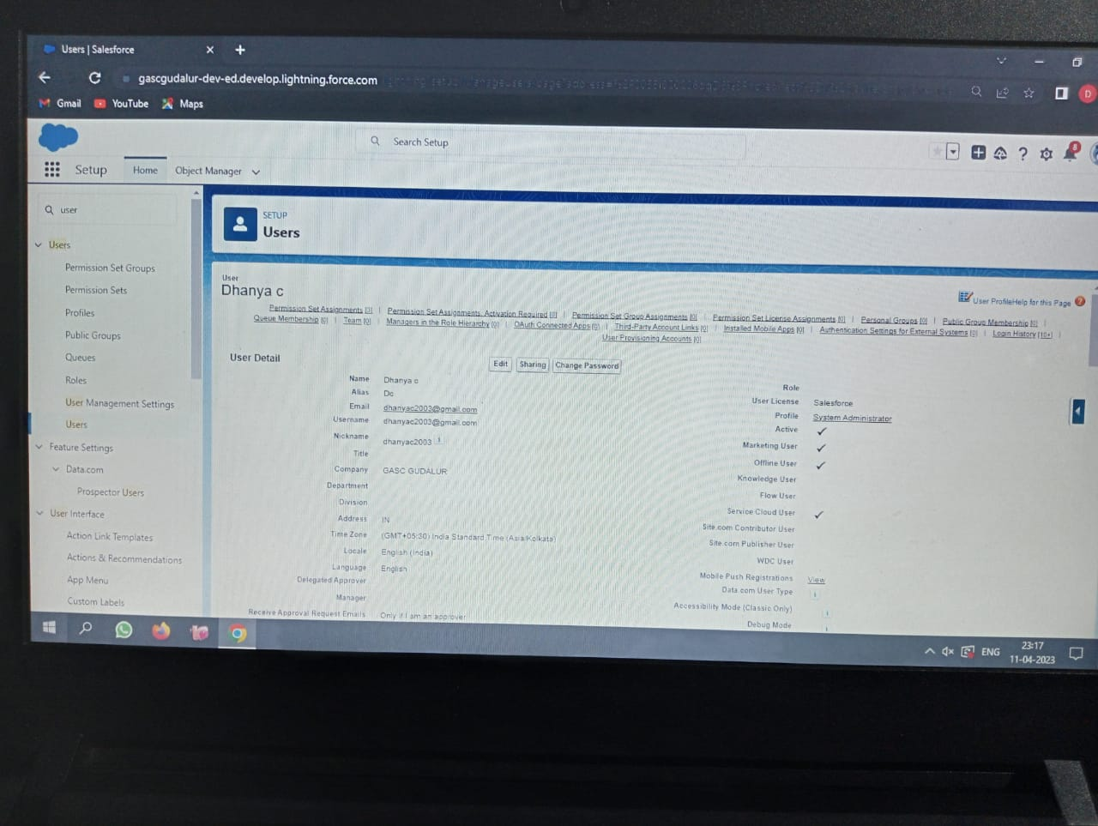



Milestone 7 – permission sets

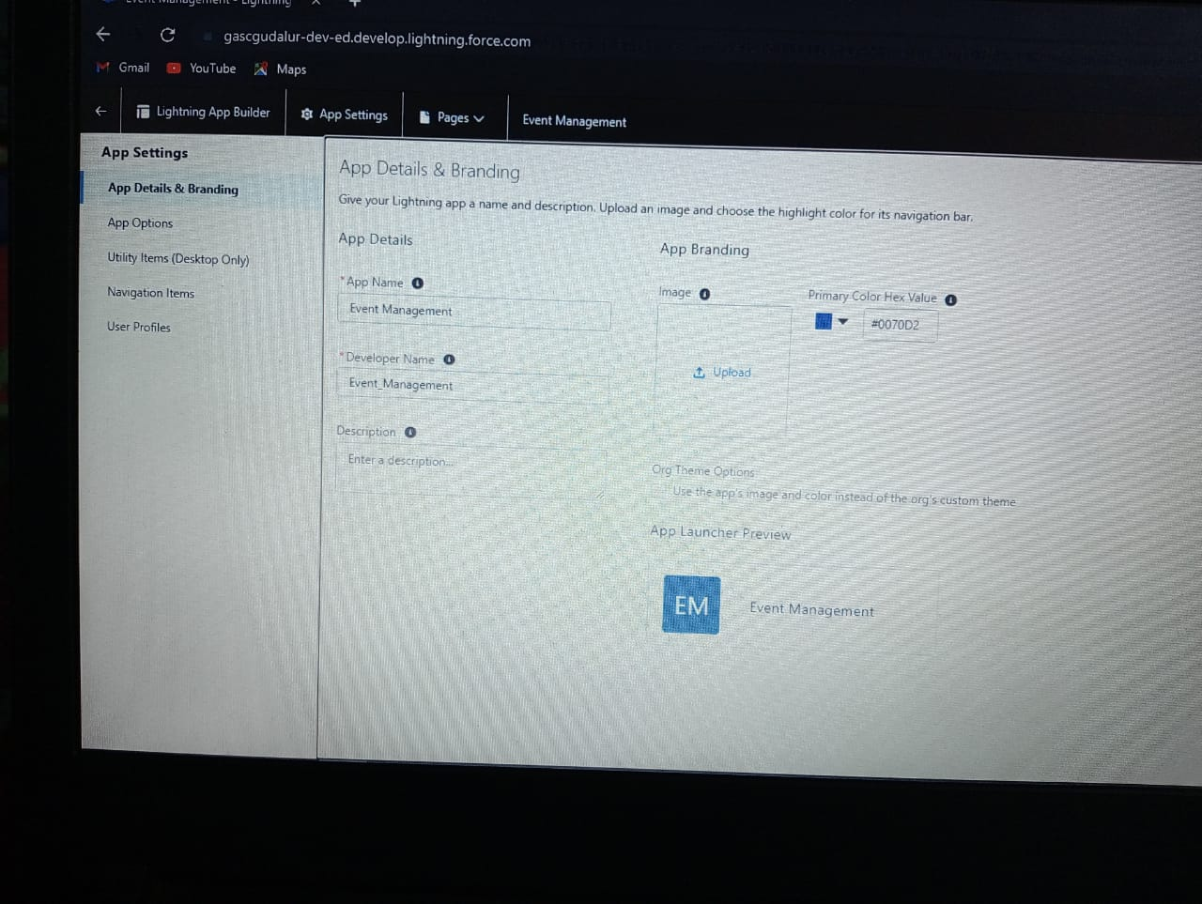

Milestone 8 – report



4. Trailhead Profile Public URL

## Team Lead –https://trailblazer.me/id/ddhanya2

## Team Member 1 –https://trailblazer.me/id/kaviya5

## Team Member 2 –https://trailblazer.me/id/punitha123

## Team Member 3 –https://trailblazer.me/id/vaijayanthi4

5. ADVANTAGES & DISADVANTAGES

* It provides integration of different services for organization needs.

* Integrates social networking platfofrms.

* Regain the inactive or old customers and increase sales by tracking customers interaction.

* It is easier to handle the data and enhance the customer and service and experience.

* It has greater community support and improve the customer basic.

DISADVANTAGES

* Difficulty in adapting the systems and spend too much time on data entry.
* Losing personal touch in the automation process.
* Costs associated with salesforce auto ation systems and maintenance.
* Difficulty integrating with other management systems.

6.APPLICATIONS

It is a collection of taps that works together as a single unit to give functionality.

* Salesforce gives standards apps such as sales clouds, centres, salesforce marketing clouds and community.
* In salesforce you can customize and existing app to matvch the method to construct novel apps by assembling standards and custom taps.

7.CONCLUSION

The different areas and multiple areas of applicatios in the field of customer relationships and its management and the utilization of data tools contain salesforce as one of the top utilized application which have become a major one among the top CRM or tool.

* This clearly resembles the recreated utilization of salesforce tool exist in the area of data reporting and analysis where still as there are many number of tools available in the current market.

8.FUTURE SCOPE

To predict future for salesforces, a quick look at the current state of CRM industry and the role played by salesforce app will help us to connect the dots and arrive at a plausible future trajectory.

* Despite the expanding the enterprise software market and the tresmendous success of tool, without a stream of new products and features, growth in an area where the challengers include the likes of IBM,SAP,Microsoft is difficulty at best.
* In the longer term, we expect saleforce to integrate data science and big data capabilities to its service cloud and marketing.
* This would result in automated customers service tasks and would let marketers leverages data for predictive targeted marketing.